AE 4342 – Lab 8

1) T = I*α

α = angular acceleration

0->4deg/min in 25min = 0.06666deg/s in 25 min 🡪 0.001164 rad/s 🡪7.75*10-7 rad/s2

T = 0.5 * 7.75*10-7 = 3.88*10-7 NM

2) T = I * α * sin(θ). However, we know the torque needed in one direction (3.88*10-7 NM). As such, keeping T constant and using the reaction wheel’s I, and θ=90-5=85 we can find the new α needed for the misaligned reaction wheel, as α = 0.0936 rad/s2

t = 25 min = 1500s 🡪 ΔRPM = 140.4rad/s = 1340.7RPM

3) 0.5*50*4 = 100 degrees

4)

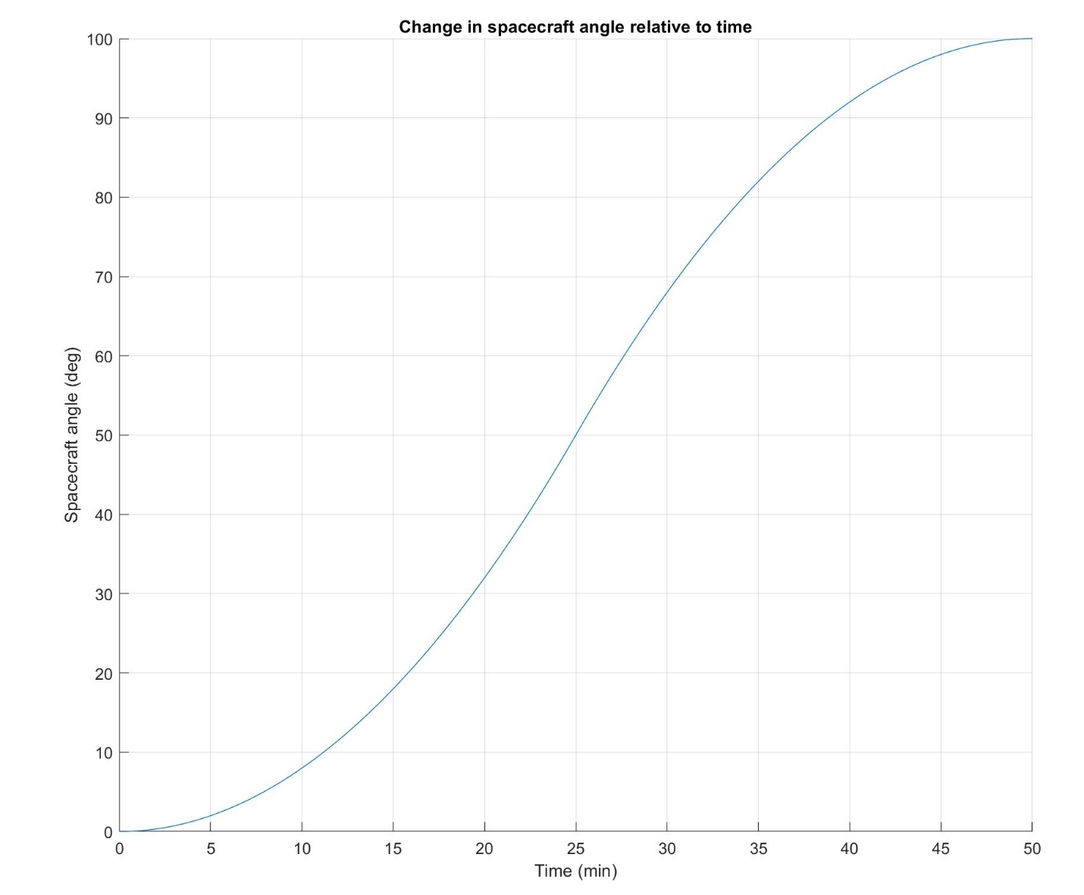

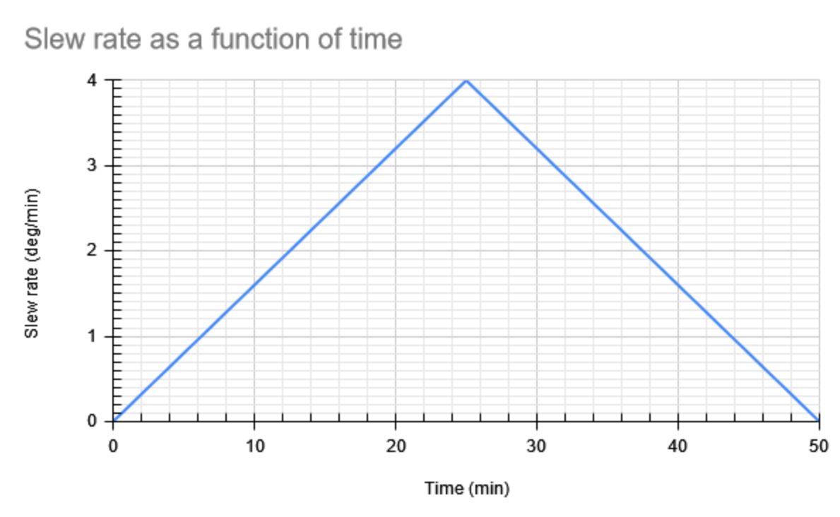

**Attitude Determination Sensors**

Inertial Measurement Unit (IMU)

|  |  |
| --- | --- |
| **NASA’s Lucy Spacecraft**  This sensor is inadequate for the Lucy Spacecraft as its mission will take a 12-year journey through space, as such, while an IMU would be appropriate in the first years, it would eventually loose accuracy and become unusable, as gyros drift. In addition, with the complex maneuvers Lucy is planning on performing IMUs will loose accuracy quicker. | **ESA’s SIMBA CubeSat**  An IMU could be used on SIMBA as the spacecraft will perform simple maneuvers around Earth and has a mission duration which is short enough for drift to be negligible. |

Sun Sensor

|  |  |
| --- | --- |
| **NASA’s Lucy Spacecraft**  Lucy could use a sun sensor for attitude determination as it will stay away from Earth for most of its mission, therefore will have an unobstructed view of the Sun for most of the time. It may temporarily lose sight of it during close approaches with asteroids, however that would only be for short amounts of time. In addition, one of its faces will be pointed towards the Sun due to its solar panels, making the use of a sun sensor even more efficient. | **ESA’s SIMBA CubeSat**  Using a sun sensor on SIMBA would be an inappropriate way to determine attitude as it will maneuver as to face the sun at times and Earth during other times. This could cause confusion in the sensor, which may think the Earth is the Sun and produce incorrect results. |

Earth Sensor

|  |  |
| --- | --- |
| **NASA’s Lucy Spacecraft**  Using an Earth sensor would make no reasonable sense on Lucy, as it will go as far away from Earth as Jupiter and will rarely be close enough to Earth to send or receive pulses from Earth, making the sensor useless for most of Lucy’s mission | **ESA’s SIMBA CubeSat**  SIMBA should use an Earth sensor as it will stay near Earth and will be able to easily see and measure Earth’s CO2 layer, enabling it to easily determine its attitude. |

Star sensor

|  |  |
| --- | --- |
| **NASA’s Lucy Spacecraft**  Lucy could use a star sensor as the stars seen from Lucy are catalogued and can be identified from their brightness, color, and position. This instrument can also help determine the spacecraft’s distance from Earth, from the difference in angle between stars as seen from Earth and the craft. | **ESA’s SIMBA CubeSat**  SIMBA could also use a star sensor as the stars around Earth are well catalogued and can help provide attitude determination for the spacecraft. |

Magnetometer

|  |  |
| --- | --- |
| **NASA’s Lucy Spacecraft**  Lucy should not use a magnetometer as it will go far beyond the Earth’s magnetosphere, effectively making the instrument useless when far from the Earth (for most of its mission). | **ESA’s SIMBA CubeSat**  SIMBA could use a magnetometer as it will be able to sense Earth’s magnetosphere throughout its mission and use it to determine attitude from the local magnetic field. In addition, these are usually small and inexpensive, which is appropriate for a small cubesat mission such as SIMBA. |